Knight News

Mother of Good Hope Council 1957
  - Volume 8 / Issue 5 June 2026
IMPORTANT INFO!
If you know of other members of the council who might not be receiving this newsletter, please pass their email information along to Tony Sachse as well so we can add them to the mailing list.

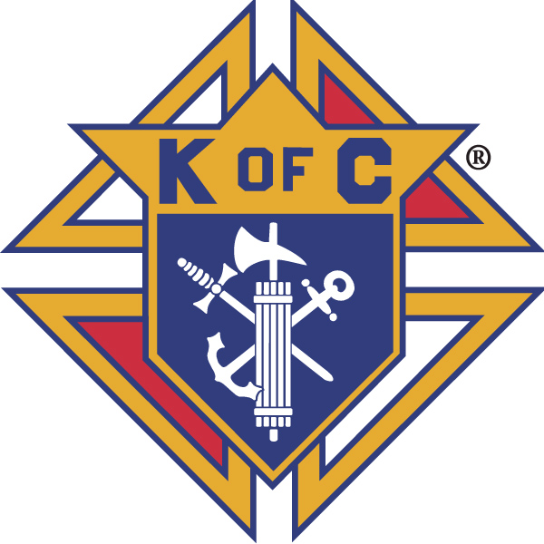

Grand Knights Corner

Grand Knight’s Notes
As we move toward the close of this fraternal year we reflect with a bit of sadness and joy on all of the changes that have beset the council this past year.
As May came to a close, we mourned the loss of our Grand Knight Leland Koeser who lost his battle to cancer. We also mourned the loss of Brother Knights, Gerald Buth, a longtime member of the council, and John Becker who was not a Knight for long but was able to make a substantial impression on the council in his limited time with us.
While we mourn the loss of these great Brother Knights, we celebrate Brother Mark Jacquette joining our council this year. While this not only added another Brother Knight to our council it allowed us to meet yet another goal, that of Star Council. We were able to meet these goals yet again and will do so in honor of our Past Grand Knight Leland Koeser.
Thank you to all of the Brother Knights who have volunteered to help set up, take down, and serve at the food stand for the Main Street Car Show next weekend. This is our major fundraiser during the summer months, and all of the support will help to ensure that it is a success. For those that are able to come out and enjoy the delicious food made in the stand as well as the funds raised go to support our charity efforts each year. It was not without a little arm twisting to fill the slots but in the end we as Knights pulled together to make sure these needs were filled.
Vivat Jesus,
Tony Sachse
Financial Secretary, Council 1957

Faith
St. Peter the Fisherman Church is always in need of volunteers for various supporting roles for weekend masses. Please consider volunteering to help demonstrate that the Knights of Columbus can be counted on as the strong right arm of the Church. To volunteer, please contact the parish.

Family
Congratulations to the winners of our council’s Knight of the Month and Family of the Month selections from this month’s meeting.
June Knight of the Month: Stan Snyder
June Family of the Month: Deacon Tom and Nancy Tomaszewski for their work helping the residents of Mueller Manor

Please keep all our Knights in your prayers. Marv Krall, Ken Drewieske, Jan Klein, and Collette Tegen as they recover from surgeries. We pray for the families of GK Leland Koeser, Gerald Buth, and John Becker on their passing. May Perpetual Light shine upon them and may they rest in peace.
The community of Knights is invited to attend the funeral services for GK Leland Koeser. It is this coming Friday. Further details are included in the email with this newsletter.

Community
Our council was selected at the host council for the 2027 Wisconsin State Council Bowling tournament. Our host committee is meeting monthly and we can always use more members. More information to come and if you are interested in being on the host committee please contact Tony Sachse, event chair.
We were finally able to present to the Miracle League of the Lakeshore the check we had intended on them receiving earlier this year. Also, thank you to the efforts of our council members we did collect $2200 this year and both Ascend Services and the Miracle League of the Lakeshore around $1000 dollars and this time we verified that the correct information was enclosed so these checks will be delivered promptly.
One of the additional event we assist in each year is SnowFest. It is July 24-26 and specifically we are looking for assistance for service at the beer tent for two different shifts. The first is 11-2 on Saturday July 25th, and the second is 11-1 on Sunday July 26th. We need 5 knights of spouses for the Saturday shift and 6 for the Sunday shift. Please let FS Tony Sachse (prince0711@charter.net) to offer to assist.
Lastly please reach out to GK elect Ed VanderBloomen if you are able to assist with the food stand at the Great American Picnic which is part of the Celebration of American Saints to be held at the Shrine in Champion. They are looking for assistance between 11-4 that date.

Life
We continue to pray for the sanctity of human life in all its forms.

Fourth Degree
The Fourth Degree completed its fraternal year and is off until this fall. We continue to look for new members for our assembly and thank you to Sir Knight David Duvall for offering to join the Honor Guard as well.
The Fourth Degree will resume meeting in September. More to come.
Facebook: Mother of Good Hope Council 1957 Knights of Columbus
Council website: www.trknights1957.com
Email us at: tworiversknights1957@gmail.com

