Knight News

Mother of Good Hope Council 1957
  - Volume 8 / Issue 4 May 2026
IMPORTANT INFO!
If you know of other members of the council who might not be receiving this newsletter, please pass their email information along to Tony Sachse as well so we can add them to the mailing list.

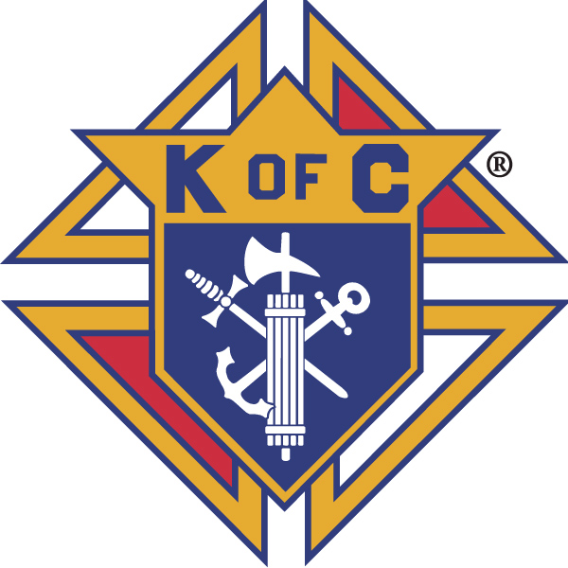

Grand Knights Corner

Grand Knight’s Notes
Fellow Brother Knights.
On this Feast of Pentecost, we rejoice in the spreading of the word that the Holy Spirit provided to the Apostles this day. It marks the end of the Easter season and in the life of the Knights of Columbus council it marks that we are near the end of the fraternal year.
It is a time to choose leaders for the new fraternal year and a time to review our past accomplishments and look toward our goals for the remaining time in the fraternal year.
We hold in prayer our Grand Knight Leland Koeser who is in hospice care and has received his Last Rites. We pray for his peaceful passing to his heavenly reward. We also pray for our departed Brother Knight Al Lewis whose beautiful singing talents will be missed by all who heard him.
We thank those Brother Knights who have stepped forward to be leaders for the new fraternal year. We will note these later in the newsletter.
We congratulate Brother Knight Marvin Krall and his wife Robyn and their family for being chosen as the Green Bay Diocese Family of the Year but also the 2025-26 Knights of Columbus State Family of the Year. More information is found below.
There are still some that have not returned their due notices, I ask you please do so ASAP.
Vivat Jesus,
Tony Sachse
Financial Secretary, Council 1957

Faith
St. Peter the Fisherman Church is always in need of volunteers for various supporting roles for weekend masses. Please consider volunteering to help demonstrate that the Knights of Columbus can be counted on as the strong right arm of the Church. To volunteer, please contact the parish.
Thank you to those Knights that are part of the 5th Sunday rosary. This is this coming Sunday May 31 before the 10am mass. Please make an effort to attend and pray together as a council this wonderful prayer.

Family
Congratulations to the winners of our council’s Knight of the Month and Family of the Month selections from this month’s meeting.
May Knight of the Month: Bob Griffe
Mayl Family of the Month: Ed and Noreen Vander Bloomen, Jr

Please keep all our Knights in your prayers. Marv Krall, Jan Klein, and Collette Tegen as they recover from surgeries. We pray for the family of Al Lewis on his passing, and we hold in prayer Leland Koeser as he nears the end of his life journey.
Brother Knight Marvin Krall and his wife Robyn along with 11 of their children attended the State Deputies banquet at the Wisconsin Knights of Columbus State convention May 16-17 where they received the Wisconsin State Council Knights of Columbus Family of the Year award. They were also awarded the Green Bay Diocesan family of the year award, and we will be having a special mass said by the bishop to honor them. More details to come. This award marks a first for our council in recent history and could not have been bestowed on a better family. 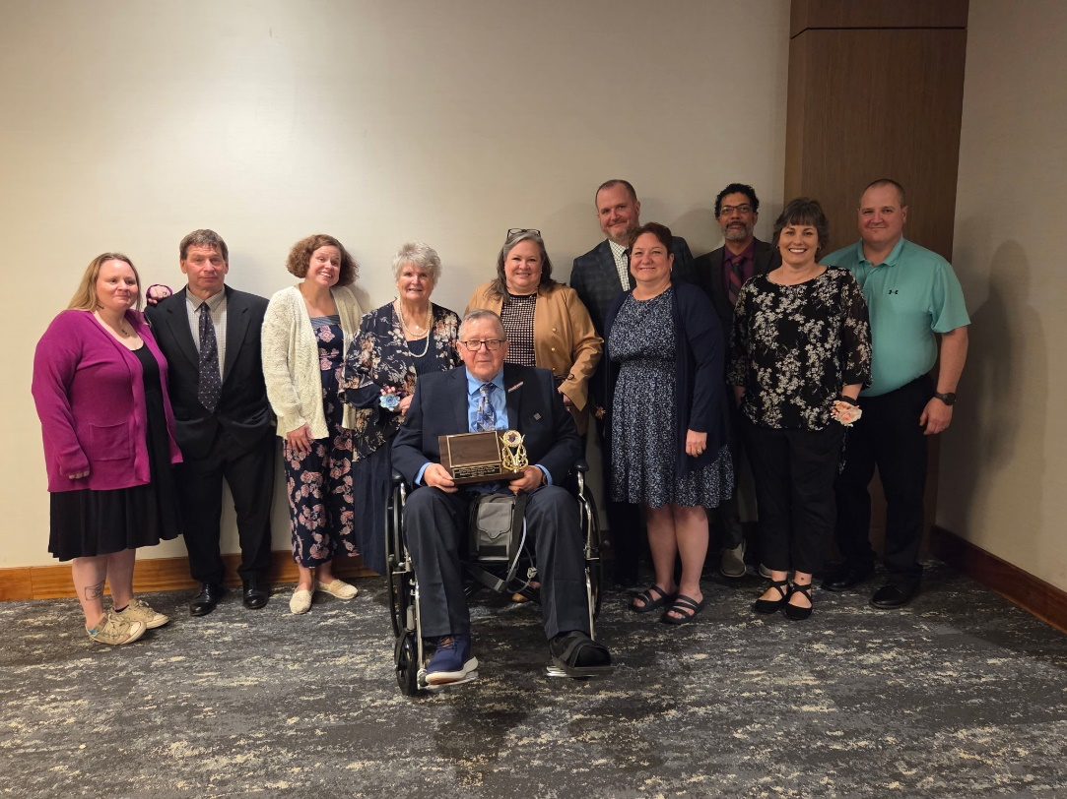
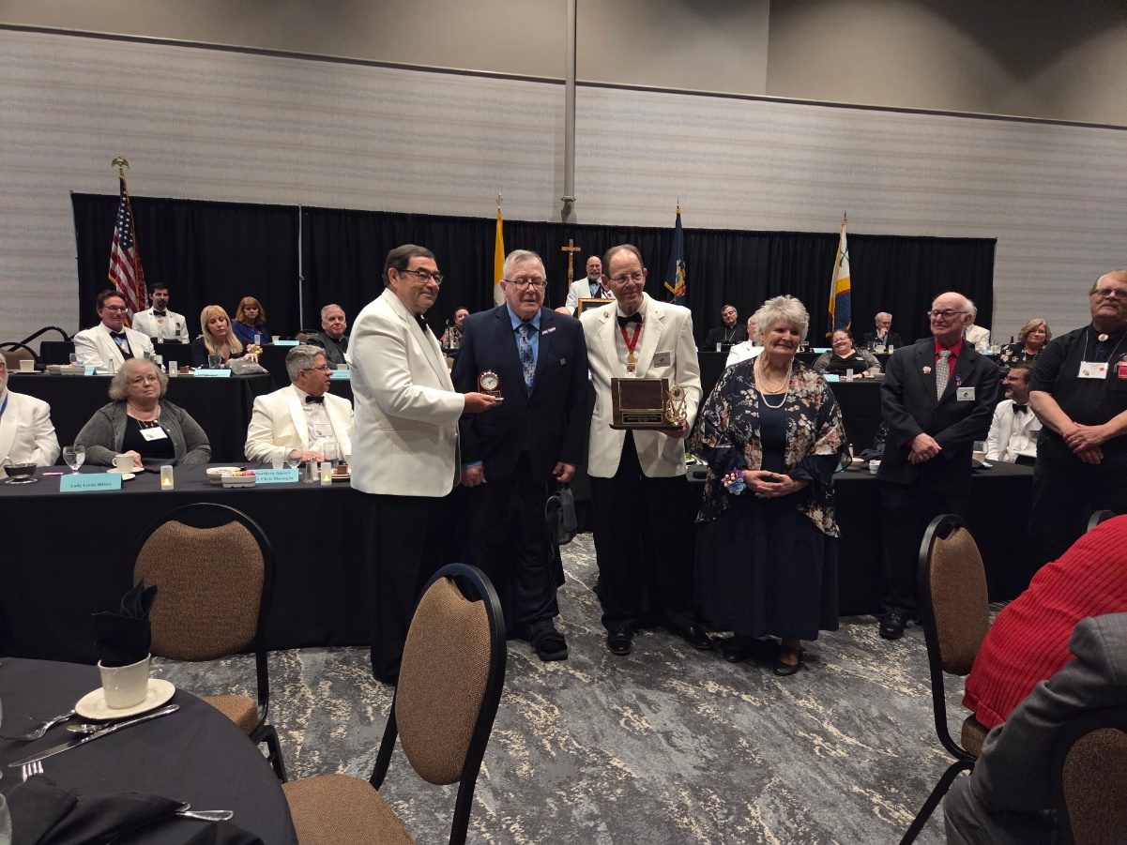

Community
Our council was selected at the host council for the 2027 Wisconsin State Council Bowling tournament. Our host committee is meeting monthly and we can always use more members. More information to come and if you are interested in being on the host committee please contact Tony Sachse, event chair.
Council members collected funds from the community during our annual Tootsie Roll drive. Thank you to Brother Knight Jeff Thompson for chairing this event. Early reports are that we raised around $2200 this year from the two locations that we were able to collect from.
We presented our two $1000 scholarships to two worthy students at Two Rivers High School. We wish congratulations to Angela Bianchi and Samantha Zipperer on receiving this awards
Also we are in need of volunteers to help with staffing our food stand at the Two Rivers Car Classic car show June 27-28. If you are able to assist please let Brother Dan Tegen know.
For the upcoming fraternal year our officers will be as follows
Grand Knight Ed Vander Bloomen, Jr
Deputy Grand Knight Sid Kemp
Chancellor Tom Mittnacht
Warden Bob Griffe
Advocate Jeff Thompson
Financial Secretary Tony Sachse
Treasurer Ray Seegers
Recorder Mike Wojta
Inside Guard Stan Snyder
Outside Guard James Linsmeier
Three Year Trustee David Duvall
Two Year Trustee Jeff Sachse
One Year Trusteee Jeff Thompson
Thank you to all of our past officers and for those that have offered to step into their new roles this coming fraternal year.

Life
We continue to pray for the sanctity of human life in all its forms.

Fourth Degree
The Fourth Degree completed its fraternal year and is off until this fall. Members of the assembly and the community joined on Sunday May 24th at the veteran’s memorial at Forest View cemetery to pay the military rosary in honor of our veterans and in honor of the 250th birthday of the United States.
The Fourth Degree will resume meeting in September. More to come.
Facebook: Mother of Good Hope Council 1957 Knights of Columbus
Council website: www.trknights1957.com
Email us at: tworiversknights1957@gmail.com

