Knight News

Mother of Good Hope Council 1957
  - Volume 8 / Issue 2 February/March 2026
IMPORTANT INFO!
If you know of other members of the council who might not be receiving this newsletter, please pass their email information along to Tony Sachse as well so we can add them to the mailing list.

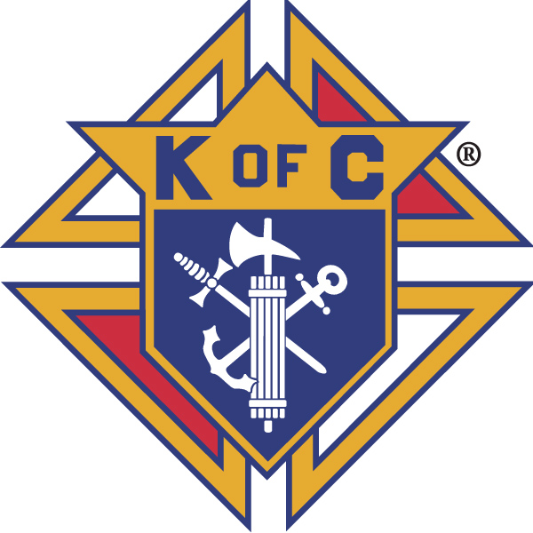

Grand Knights Corner

Grand Knight’s Notes
Fellow Brother Knights.
As we near Easter we prepare for the sacrifice that Jesus make for us and for his rebirth on Easter Sunday. It is in the life of a council that we also go through a period of reflection and rebirth as well. I believe this is the time for our council to do this as well.
We reflect on all of the accomplishments that our council has had over the last few years, the growth, the donations, and the good will we have spread through the community. However, we also reflect on those Knights lost. Not only those who have met their eternal reward but also those that are no longer active in the council. We must ask ourselves why this has happened and work toward reversing this trend. If you know a Brother Knight that doesn’t attend meetings, invite him to the next one. If needed offer to pick him up, or maybe even just meet for some coffee and fellowship.
A sincere welcome to our two newest Knights, Joe Parma and Daniel Zachek who were exemplified into the council over the last few weeks. We also have two additional candidates approved by the council that we hope to exemplify soon. This would leave us one Knight short of our membership quota for Star Council.
Second notices, raffle tickets and Fraternal service surveys were all mailed to all members. Please return all of these items as soon as possible.
Vivat Jesus,
Tony Sachse
Financial Secretary, Council 1957

Faith
St. Peter the Fisherman Church is always in need of volunteers for various supporting roles for weekend masses. Please consider volunteering to help demonstrate that the Knights of Columbus can be counted on as the strong right arm of the Church. To volunteer, please contact the parish.
Thank you to those Knights that are part of the 5th Sunday rosary. We are planning for the year ahead. So please keep an eye out for the 4 opportunities in 2026 to join together and celebrate the power of prayer. Keep on eye out for the schedule for 2026. Our next opportunity is coming this Sunday before the 10 AM mass, please consider attending.
Our council did receive our RSVP rebate for our support of Brother Joseph Cullen. This was directed to the Dominican province that he is serving in.

Family
Congratulations the winners of our council’s Knight of the Month and Family of the Month selections from this month’s meeting.
February Knight of the Month: no meeting
February Family of the Month: Steve and Lauri Bacalzo
March Knight of the Month: Tom Clarksen
March Family of the Month: The Tim Lohr Family
Please keep all our Knights in your prayers. Marv Krall, Al Lewis, and Leland Koeser’s daughter in law Diane who passed away recently.

Community
Our council was selected at the host council for the 2027 Wisconsin State Council Bowling tournament. Our host committee is meeting monthly and we can always use more members. More information to come and if you are interested in being on the host committee please contact Tony Sachse, event chair.
The 5th Annual Cornhole Tournament raised 3070.94 after expenses. A motion was raised to use charity funds from the council to make a total donation of $4000 to the Harper Group, the beneficiary of this years event.
The council will be providing two scholarships to Two Rivers High School students this year. They are Angela Bianchi and Samantha Zipperer.
The council also voted to spend $250 to register as a food vendor at the cash show and to reimburse Jeff Thompson $140 for Tootsie Rolls to used in our drive in the spring that purchased.

Life
The council did receive a $300 ASAP program rebate which was forward to the Crossing. This is from the donation we made for the baby box campaign in the fall.

Fourth Degree
There is an upcoming exemplification April 11th at Our Lady of Lourdes parish in DePere. We are in need of two more Knights to consider ascending to the Fourth degree to help the assembly reach Star Assembly this year. Please consider joining the patriotic degree. If you are interested please reach out to either FN Jeff Sachse, FA Ed VanderBloomen or FC Tony Sachse to get the process going. The assembly covers the cost for those willing to join the 4th Degree.
Facebook: Mother of Good Hope Council 1957 Knights of Columbus
Council website: www.trknights1957.com
Email us at: tworiversknights1957@gmail.com

