Knight News

Mother of Good Hope Council 1957
  - Volume 8 / Issue 3 April 2026
IMPORTANT INFO!
If you know of other members of the council who might not be receiving this newsletter, please pass their email information along to Tony Sachse as well so we can add them to the mailing list.

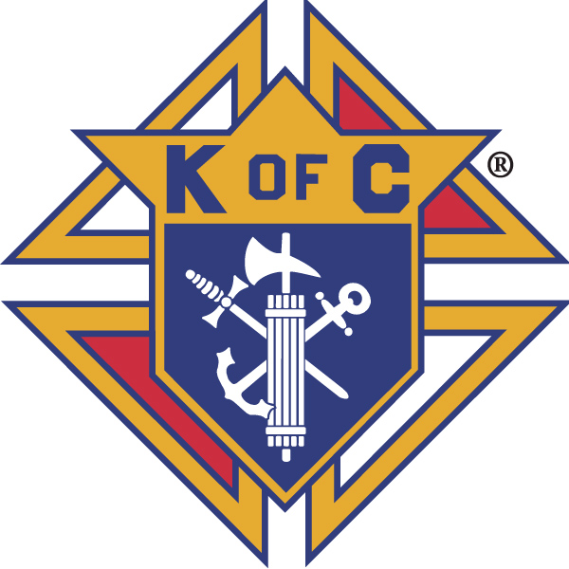

Grand Knights Corner

Grand Knight’s Notes
Fellow Brother Knights.
As we have gone through the season of Lent and Jesus’s rebirth on Easter, we look toward our rebirth both personally and as a council. In the life of this council this rebirth takes on several forms.
We welcome the addition of two new Knights to our council. Brother Joe Bianchi and Robert Strieter joined our council at our last council meeting. This leaves us one member short of our goal for Star council. I ask that you all think of who could be a valued addition to our council might be to simply ask them if they have thought about becoming a Knight of Columbus. We do so many great things for the community and people need to hear more from our group about what we do.
We also extend our sincere Thank YOU to our Grand Knight Leland Koeser. As you all know he is facing challenges with an incurable brain tumor. He has chosen to tour the country and spend time with his family during the end of his life. We thank him for the courage to step up and lead our council and for everything he has done in service of our council.
We thank Brother Knight Ed Vander Bloomen, Jr., for his willingness to step in as Deputy Grand Knight and now as acting Grand Knight as we finish out this fraternal year.
We face rebirth personally and as a council during this time. We do so together as a council bound by charity, unity, and fraternity
There are still some that have not returned their due notices, I ask you please do so ASAP. Also, we need all raffle tickets you have sold to be returned ASAP as well.
Vivat Jesus,
Tony Sachse
Financial Secretary, Council 1957

Faith
St. Peter the Fisherman Church is always in need of volunteers for various supporting roles for weekend masses. Please consider volunteering to help demonstrate that the Knights of Columbus can be counted on as the strong right arm of the Church. To volunteer, please contact the parish.
Thank you to those Knights that are part of the 5th Sunday rosary. We are planning for the year ahead. So please keep an eye out for the 4 opportunities in 2026 to join together and celebrate the power of prayer. Keep an eye out for the schedule for 2026.

Family
Congratulations to the winners of our council’s Knight of the Month and Family of the Month selections from this month’s meeting.
April Knight of the Month: Ken Drewieske
April Family of the Month: Sandy Abts

Please keep all our Knights in your prayers. Marv Krall, Al Lewis, and Leland Koeser.

Community
Our council was selected at the host council for the 2027 Wisconsin State Council Bowling tournament. Our host committee is meeting monthly and we can always use more members. More information to come and if you are interested in being on the host committee please contact Tony Sachse, event chair.
Cornhole tournament chairs Kelly Hilliker and Dan Tegen presented our $4000 donation to members of the Harper Group Board of Directors. They are pictured below.
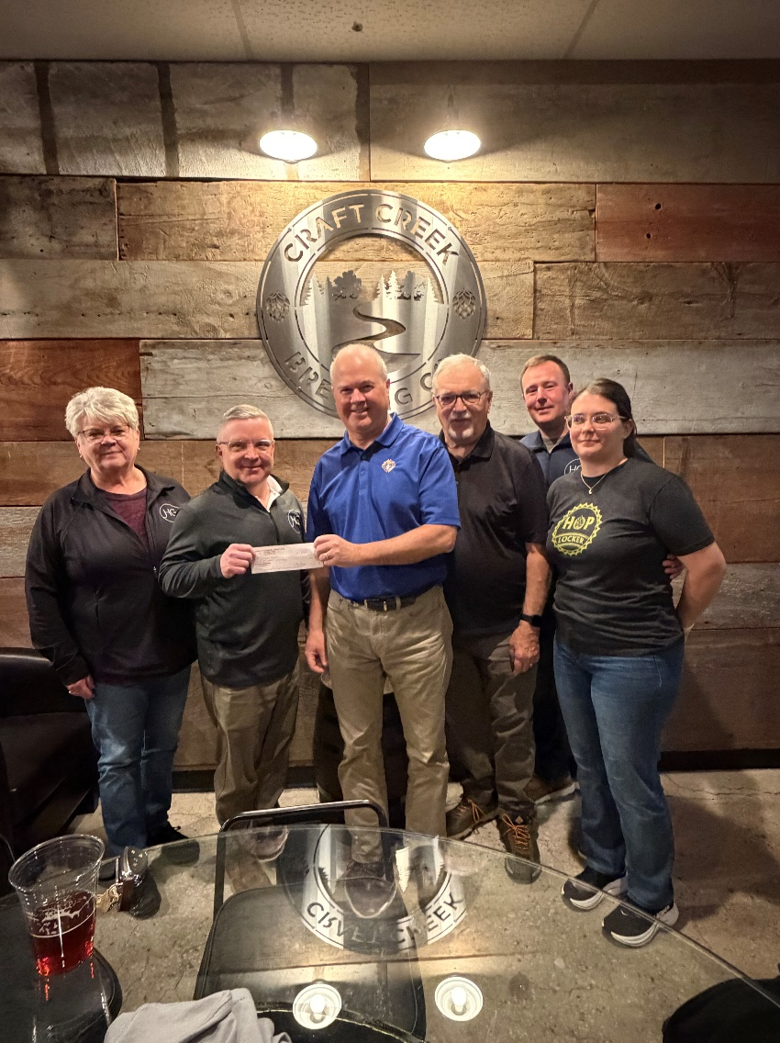
Thank you to all of those that helped to sell raffle tickets at the parish the weekends of April 11-12 and April 18-19.
Thank you also to all of the members that have offered to sell Tootsie Rolls in early May. There are still shifts open at the two locations we will be handing them out: Piggly Wiggly and Pick N Save. Please let Brother Jeff Thompson know if you are interesed in helping out.

Life
We continue to pray for the sanctity of human life in all its forms.

Fourth Degree
We welcome our newest Sir Knights Jim Decker and Charles Reinhart. This brings us to the Four Sir Knights that we need to complete our Star Assembly award this year. Thank you to all who have joined our Assembly this year. We have our end of the year banquet coming up at Rita’s Supper Club on May 13th. Social hour starts at 5:00 and the dinner at 6:00. Cost is $25/person. Dinner is family style Chicken and beef tips. Please let FN Jeff Sachse or FC Tony Sachse know if you are interested in attending. We need a final head count by May 6th.
Facebook: Mother of Good Hope Council 1957 Knights of Columbus
Council website: www.trknights1957.com
Email us at: tworiversknights1957@gmail.com

