Knight News

Mother of Good Hope Council 1957
  - Volume 7 / Issue 8 September 2025
IMPORTANT INFO!
If you know of other members of the council who might not be receiving this newsletter, please pass their email information along to Tony Sachse as well so we can add them to the mailing list.

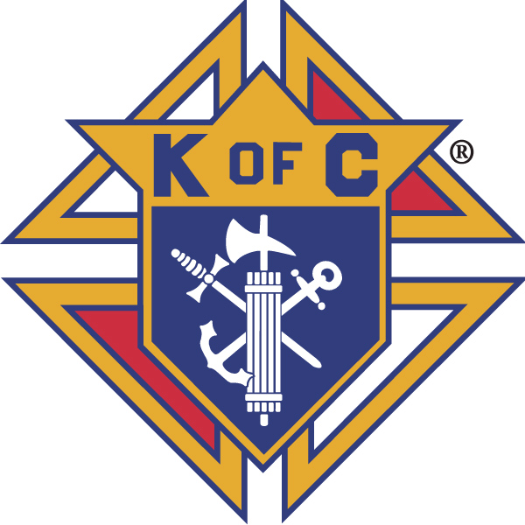

Grand Knights Corner

Grand Knight’s Notes
Fellow Brother Knights.
On Sunday, September 7th the two newest Saints were canonized to the church. Saint Carlo Acutis, the first millennial saint, and Saint Pier Giorgio Frascati. Both young Italian men the chose to let God lead their lives.
In his homily at the canonization mass his Holiness, Pope Leo XIV spoke to this and recalled Saint Francis of Assisi asking, “What is it you want from me Lord?” as he struggled with his pursuit of fame and wealth as he questioned his path forward.
Often, we are challenged with the day to day struggle of what is the best path. We ask how we can best serve the Lord in everything that we do and sometimes find that we are doing things that we might feel are the best representations of ourselves and what God would want us to do. We have opportunities through the Knights in service to our church which can help to define what the Lord has called us to do. However, when we are challenged with a choice of the correct path, we just need to ask, “What is it you want from me Lord?” From Saint Francis of Assisi to the most recent Saints Carlo and Pier Giorgio we find that asking this simple question often provides us a most profound answer.
We also welcome our newest Knight Dennis Weber who transfers to our Council from Council 4807 and also joins our Fourth Degree assembly as a transfer from Assembly 1212
Vivat Jesus,
Tony Sachse
Financial Secretary, Council 1957

Faith
St. Peter the Fisherman Church is always in need of volunteers for various supporting roles for weekend masses. Please consider volunteering to help demonstrate that the Knights of Columbus can be counted on as the strong right arm of the Church. To volunteer, please contact the parish.
We will be providing support to the Parish Festival soon to come through helping with the food as well as being able to sell them our hamburgers that we didn’t sell at Brian Lee Day. We will be looking for some knights to assist with this, please reach out to Brother Sid Kemp if you can assist.


Family
Congratulations the winners of our council’s Knight of the Month and Family of the Month selections from this month’s meeting.
September
Knight of the Month: Ed Vander Bloomen
Family of the Month: Tom and Maria Mittnacht
Please keep all of our members and their families in your prayers this month especially those that might be sick or in distress.

Community
The council has ordered four cases of coats for the Coats For Kids program this fall. They will be split between TREP and the Salvation Army. They are scheduled to be delivered in the next few weeks and we will work to get them out to the organizations as soon as we receive them.
Members of the council and their ladies are invited to the District 12 Landing Day Banquet. It is Monday, October 13th at City Limits Bar and Grill/3627 County CR/Manitowoc, WI
Social starts at 5:30 with the program and meal at 6:30. Speaker for the evening is Father Nico (Nicholas) Stellpflug who was ordained to the priesthood June 2025. He will share some reflections from his time in the seminary and his early pastoral experiences.
The meal is family style with two meats and all of the fixings. Cost is $25/person and can be paid to the council prior to the event. We have to provide a final count to the Manitowoc Council 710 no later than October 3rd so I would ask if possible that no later than September 30th that we have our final numbers to either the Grand Knight or the Financial Secretary.
Also, at this most recent council meeting we voted to host a calendar raffle during Advent as a way to make up for the loss of the Kites on the Lakeshore fundraiser in the summer. Also we will be hosting a pancake breakfast in November or December. More to come on this.

Life
We will work with the Knights of District 12 as part of the Forty Days for Life as part of prayer and support near the Planned Parenthood in Manitowoc. Brother Tom Mittnacht has more information on the dates and times we are asked to be present if you are interested in joining in this event.
We continue to collaborate with the Knights of District 12 to help with the baby box project at the Crossing. At this time there isn’t any further update to provide but we will make sure to pass information along as we get it.

Fourth Degree
There is an upcoming Exemplification of the Fourth Degree Saturday October 13th in Beaver Dam. There are also plans to be developed for an Exemplification to be held in January in Manitowoc. If you are interested in advancing to the Fourth Degree please reach to FN Jeff Sachse, or FC Tony Sachse. The assembly does pay the cost of the exemplification.

Facebook: Mother of Good Hope Council 1957 Knights of Columbus
Council website: www.trknights1957.com
Email us at: tworiversknights1957@gmail.com

