Knight News

Mother of Good Hope Council 1957
  - Volume 7 / Issue 8 September 2025
IMPORTANT INFO!
If you know of other members of the council who might not be receiving this newsletter, please pass their email information along to Tony Sachse as well so we can add them to the mailing list.

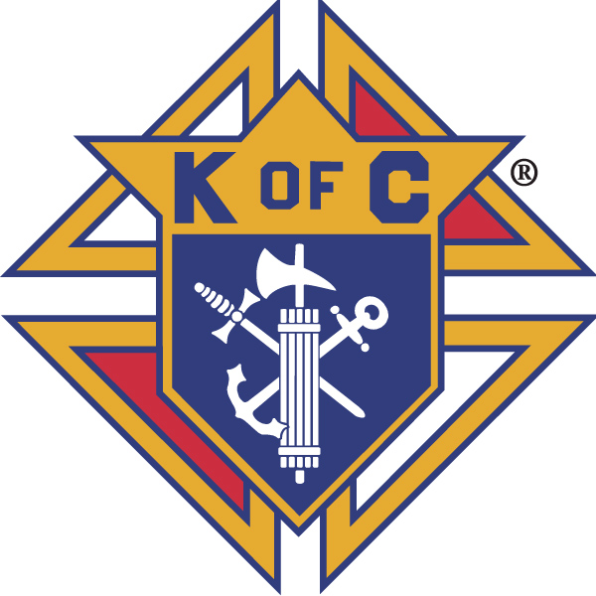

Grand Knights Corner

Grand Knight’s Notes
Fellow Brother Knights.
As we are at the start of our new fraternal year I am left to ask. What can we do to be more like Jesus Christ and be giving of ourselves? In a recent issue of the Columbian our Supreme Chaplain Archbishop Lori challenged the Knights to” identify one way you can demonstrate true love of God and neighbor.” To then pray about how to put this into action and then do it. Each act that we as Knights do for the community is for our love of neighbor. Whether it is a large fundraiser or something as simple as helping at the parish. I ask us all to reflect on this as we continue forward in the fraternal year.
We show our commitment to our faith and the organization through helping it to grow. The more Brother Knights we have to work together with, the broader our reach can become. We are challenged to again add 9 new members to our council for our membership goal as well as continue our active program history.
As we continue on in this fraternal year, my Brother Knights I ask, what more can we do to show our love to God and to our neighbor?
Vivat Jesus,
Tony Sachse
Financial Secretary, Council 1957

Faith
St. Peter the Fisherman Church is always in need of volunteers for various supporting roles for weekend masses. Please consider volunteering to help demonstrate that the Knights of Columbus can be counted on as the strong right arm of the Church. To volunteer, please contact the parish.
We will be providing support to the Parish Festival soon to come through helping with the food as well as being able to sell them our hamburgers that we didn’t sell at Brian Lee Day. We will be looking for some knights to assist with this.
We continue to have a growing group after our monthly meeting that hangs around to pray the Chaplet of Divine Mercy following the business meeting. Additionally, if the meeting runs less than one hour this is used as the closing prayer for the meeting in support of our intentions for the meeting and those mentioned as part of the good of the order. It is truly uplifting to see the group of men praying for something more. The spirit of community and the power of our prayer is evident. I ask that more of our brothers consider joining.
It is the Fifth Sunday of the month this coming Sunday. We’d like all Knights to sit together on Sunday at the 10:00 mass as we will be praying the rosary between the two masses. This show of togetherness can impress upon others the value that we place on our Faith as a key part of our history.

Family
Congratulations the winners of our council’s Knight of the Month and Family of the Month selections from this month’s meeting.
July
Knight of the Month: Stan Snyder
Family of the Month: Tony and Sue Sachse
Please keep all of our members and their families in your prayers this month.

Community
Thank you to all that assisted at our summer fundraisers. These activiites help to fund all of the charitable works that we do each year. The council did vote to order four cases of coats for the Coats For Kids program this fall. They will be split between TREP and the Salvation Army. Program Director Tony will work with these groups to make sure that the right sizes are ordered. By ordering early we are able to take advantage of a discount through the State Council which is equal to around 50% off the original cost.
Members of the council and their ladies are invited to the District 12 Landing Day Banquet. It is Monday, October 13th at City Limits Bar and Grill/3627 County CR/Manitowoc, WI
Social starts at 5:30 with the program and meal at 6:30. Speaker for the evening is Father Nico (Nicholas) Stellpflug who was ordained to the priesthood June 2025. He will share some reflections from his time in the seminary and his early pastoral experiences.
The meal is family style with two meats and all of the fixings. Cost is $25/person and can be paid to the council prior to the event. We have to provide a final count to the Manitowoc Council 710 no later than October 3rd so I would ask if possible that no later than September 30th that we have our final numbers to either the Grand Knight or the Financial Secretary.

Life
We continue to collaborate with the Knights of District 12 to help with the baby box project at the Crossing. At this time there isn’t any further update to provide but we will make sure to pass information along as we get it.

Fourth Degree
Members of both the Manitowoc and Two Rivers Assemblies met this month to conduct an Installation of Officers for the coming Fraternal Year. We were joined by the Eastern District Master Jack Wrbanich who noted an upcoming exemplification in Beaver Dam in October and one also to be scheduled this January in Manitowoc. We will begin out business meetings on the second Wednesday of each month starting in September.

Facebook: Mother of Good Hope Council 1957 Knights of Columbus
Council website: www.trknights1957.com
Email us at: tworiversknights1957@gmail.com

